Supplementary Information for **Mapping literature reviews on coral health: A review map, critical appraisal, and bibliometric analysis**

**Contributing authors:**

Samantha Burke, Patrice Pottier, Erin L. Macartney, Malgorzata Lagisz, Tracy Ainsworth, Szymon M. Drobniak, & Shinichi Nakagawa

**Table of Contents:**

**Figure S1.** Additional main topics identified in coral health secondary literature

**Figure S2.** Extracted terms and when the reviews were published.

**Figure S3.** Prevalence of terms extracted within only systematic-like reviews

**Figure S4.** Word cloud of all keywords for coral health secondary literature

**Figure S5.** Country collaboration network coloured by country’s level of development (Human Development Report 2021/2022)

**Figure S6.** Author collaboration network

**Figure S7.** Number of systematic-like reviews published over time

**Table S1.** Exclusion decision examples

**Table S2.** Key terms to identify from papers and their definitions

**Table S3.** Altmetric data summary for collated coral health reviews

**Table S4.** Reviews that are top performing within each Altmetric category

**Figure S1.** Additional main topics identified in coral health secondary literature. Plot created using *ggplot2* package in R (version 3.4.0, Wickham, 2016). Labels denote actual percentage of all coral health reviews examined that include that topic. **A.** Percentage of each category of additional terms found in the literature out of all papers examined that discuss the category. Terms grouped into four categories as described in methods: 1) biochemical responses (“bioaccumulation,” “chlorophyll,” “functional gene,” “genetic,” “genetic response,” “immune response,” “metabolism,” “photobiology,” “photosynthesis,” “pigmentation,” “productivity,” “respiration,” and “signaling molecules”), 2) biophysical drivers (“accretion,” “depth,” “salinity,” “sea level,” “water flow,” and “wind”), 3) reef-scale processes (“aging,” “algae,” “competition,” “connectivity,” “growth,” “herbivory,” “hybridization,” “interaction,” “phase shift,” “recruitment,” “reproduction,” “succession,” and “transmission”), and 4) others (“aquaculture,” “captivity,” “evolution,” “feedback loop,” “life history,” “marine protected area”, “physiology,” “science communication,” and “soft coral”). **B.** The percentage of each term found out of all collected papers.

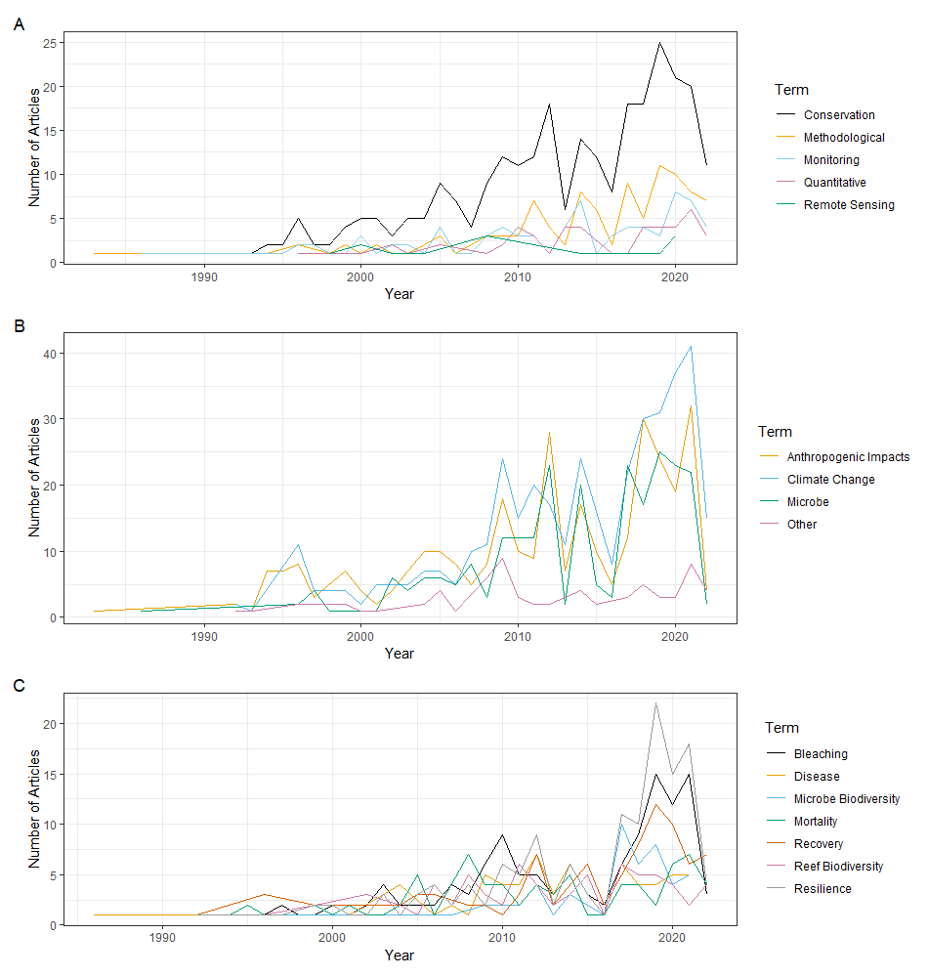

**Figure S2.** Extracted terms and when the reviews were published. Plot created using *ggplot2* package in R (version 3.4.0, Wickham, 2016). Y-axis increases as the term is found in more articles published in that year. All terms as described in protocol (Burke et al., 2022). **A.** Approach and purpose terms. **B.** Drivers of change in coral health terms. 17 driver terms combined into four categories for visualisation purposes. The anthropogenic impacts category includes the terms anthropogenic impacts, human damage, chemical exposure, pollution, and fishing. The climate change category includes the terms climate change, increased sea surface temperature, UV radiation, acidification, calcification, and bioerosion. The microbe category includes the terms pathogen, microbiome, and symbiosis. The other category includes the terms habitat range shift, predation, and wave damage. **C.** Coral health outcome terms.

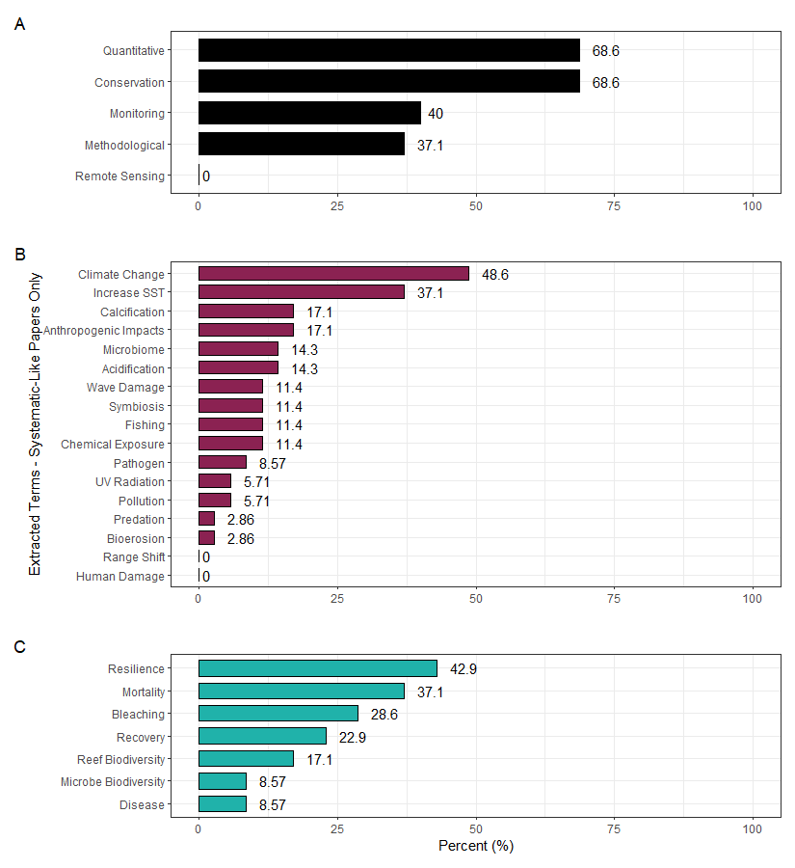

**Figure S3.** Prevalence of terms extracted within only systematic-like reviews. Labels denote actual percentage of papers examined that include that term or closely related terms. All terms as described in protocol (Burke et al., 2022). Plots created using *ggplot2* package in R (version 3.4.0, Wickham, 2016). **A.** Approach and purpose terms. **B.** Drivers of change in coral health terms. **C.** Coral health outcome terms.

**Figure S4.** Word cloud of all keywords for coral health secondary literature. Larger words (with a corresponding colour change) indicate greater incidence. Cloud created using the R packages *tm* (version 0.7-11, Feinerer et al., 2008) and *wordcloud* (version 2.6, Fellows, 2018).

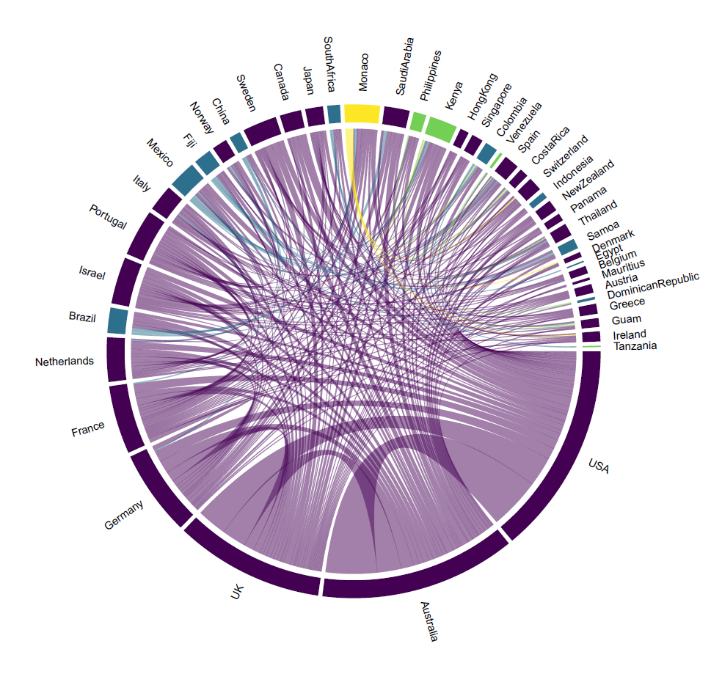

**Figure S5.** Country collaboration network coloured by country’s level of development (Human Development Report 2021/2022). Purple indicates “very high human development” ranking in the Human Diversity Index (HDI). Blue indicates “high human development” ranking in the HDI. Green indicates “medium human development” ranking in the HDI. Yellow indicates countries which did not have a HDI ranking in 2022. Plot created using *bibliometrix* (version 4.1.0, Aria and Cuccurullo, 2017) and *circlize* (version 0.4.15, Gu et al., 2014) R packages. Lines connect the affiliated countries between two collaborating authors. The portion of the circumference for each country increases as more authors producing coral health secondary literature are affiliated with that country.

**Figure S6.** Author collaboration network plot created using *bibliometrix* R package (version 4.1.0, Aria and Cuccurullo, 2017). Circles denote a cluster of authors collaborating on a single paper together. Dashed lines connect collaborating authors across papers.

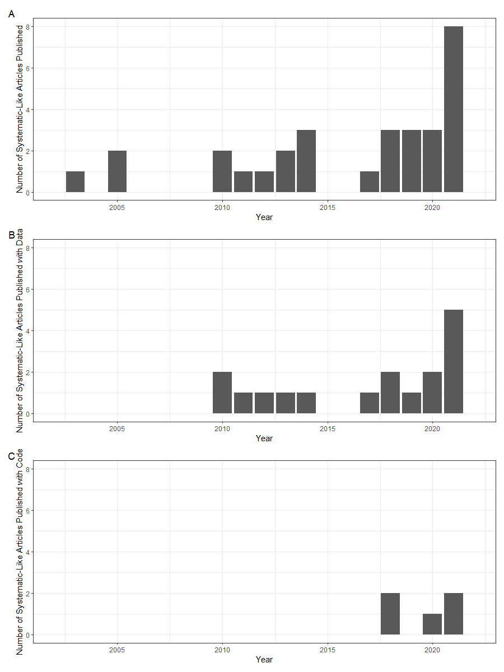

**Figure S7.** Number of systematic-like reviews published over time. Plot created using *ggplot2* R package (version 3.4.0, Wickham, 2016). **A.** All systematic like reviews. **B.** Systematic-like reviews which provide data. **C.** Systematic-like reviews which provide code.

**Table S1.** Exclusion decision examples.

|  |  |
| --- | --- |
| **Paper DOI or Citation** | **Exclusion Reason** |
| 10.1007/978-3-030-20389-4_13 | Not peer reviewed |
| 10.1126/science.aad9957 | No abstract |
| Hughes, T. 1993. Disturbance: effects on coral reef dynamics. *Coral Reefs* 12(3-4) 117-233. | Text unavailable |
| 10.5194/bg-18-5117-2021 | Wrong study type |
| 10.1016/j.chemosphere.2021.131675 | Not coral health |

**Table S2.** Key terms identified from papers and their definitions. The terms are grouped into three categories representing, respectively: 1) methodology or purpose of the paper, 2) coral health outcomes, and 3) drivers of coral health change, as considered in the included papers.

|  |  |
| --- | --- |
| **Key Terms** | **Definition** |
| METHODOLOGY OR PURPOSE OF PAPER | |
| Quantitative Synthesis (computational synthesis, mathematical synthesis) | Paper uses statistical analysis to compute an assessment of secondary data |
| Methodological | Paper reviews methods for collecting data or conducting research |
| Remote Sensing (satellite sensing, remote-collection, satellite-collection) | Paper incorporates or evaluates satellite-collected data |
| Monitoring (surveying, routine observation, annual surveys) | Paper evaluates monitoring efficacy or incorporates in situ assessment of an environment over time (key term for identifying in situ work: surveys, observations) |
| Ecosystem Management/Conservation | Review was conducted to provide information for monitoring (sometimes), restoring, and/or maintaining reefs ecosystems such as assessing human impacts on a coral reef (as opposed to papers that examine physiology of corals which are more indirectly related to conservation and management) |
| CORAL HEALTH OUTCOMES | |
| Bleaching | Paper examines bleaching (ejection of symbiotic zooxanthellae) in corals |
| Disease | Paper examines illness caused by pathogens, typically identified through visual symptoms |
| Biodiversity of coral reef assemblage | Paper examines/discusses the collection of coral species within the community |
| Biodiversity of microbial community | Paper examines/discusses the collection of bacterial/microbial species within a coral microbiome |
| Coral and/or Coral Reef Resilience/Tolerance/Adaptability | Paper examines the survivability, resilience, ability (or lack thereof) to withstand conditions or change (measuring coral cover alone does not count, must explicitly state survivability or resilience against a stressor to count) - symbionts as protective factors included |
| Coral Recovery/Restoration/Rehabilitation | Paper examines the return, recovery, or rehabilitation of coral reefs (measuring coral cover alone does not count, must state term recovery or a rise in coral cover, increase biodiversity or species richness, decrease in disease prevalence/severity, decrease in bleached corals to count as return/recovery); includes papers that evaluate the success of recovery/restoration efforts (e.g., ability of Marine Protected Areas to facilitate recovery) |
| Coral Cover/Mortality | Paper examines change in coral cover (amount of substrate covered by live coral) or mortality of coral (death rates) |
| DRIVERS OF CORAL HEALTH CHANGE | |
| Pathogen (virus, bacteria, viral agent) | Paper identifies or describes a carrier of a disease |
| Microbiome (holobiont, symbionts) | Paper looks at coral microorganisms (includes pathogens, coral "holobiont", etc.) |
| Symbiosis | Paper examines the mutual relationship between two organisms, usually the coral and a bacteria or algae (focus on relationship; can include papers with one microorganism or many) |
| Climate Change | Paper examines the impacts of climate change on coral reef environments; should use the words climate change or close synonyms (e.g., global change, climate warming, global warming, etc.) but not the specific climate impacts that characterize climate change (e.g., increased temperatures, increased CO2, etc.) |
| Anthropogenic Impacts | Paper examines impacts of human influence on coral reef environments; should use the words anthropogenic impact or close synonyms (e.g., anthropogenic influences, human impacts, human influences, etc.) but not the specific anthropogenic impacts that characterize anthropogenic impacts (e.g., fishing, pollution, etc.) |
| Habitat Range Shift (change in geographic range) | Paper examines the influence of a new species entering reefs or the expansion of corals into new areas or disappearing from old ones |
| Increased Sea Surface Temperature | Paper examines the influence of increasing sea surface temperatures impacting coral reef environments |
| UV Radiation | Paper examines the influence of UV radiation on corals |
| Predation (e.g., invasive species) | Paper examines the influence/presence of predators or invasive species on coral health |
| Acidification (acidify, lowered pH, more acidic waters) | Paper examines the influence of the oceans becoming more acidic on coral health, doesn't need to directly mention the calcification of the coral skeleton |
| Calcification (calcify, calcified) | Paper examines/discusses corals' ability to build a calcareous skeleton (see separately acidification, though these may often go together) |
| Bioerosion (biodegradation - breakdown of organic material through bacterial means) | Paper discusses bioerosion; may be similar to the ideas of acidification and reducing calcification (usually linked with these), but bioerosion describes more generally the breakdown of hard materials in the ocean (specifically in this case, the calcareous skeleton of the coral) |
| Physical Damage - Wave Action (e.g., storms/cyclones/hurricanes) | Paper examines the influence of storms (e.g., through storm damage) on corals; if paper only says generally "damage" select both wave action and human physical damage |
| Physical Damage - Human (e.g., boating, tourism, land development, shipwreck) | Paper examines the influence of physical damage to reefs caused by humans (e.g., tourism, boating, etc.) on coral health; if paper only says generally "damage" select both wave action and human physical damage |
| Chemical Exposure (e.g., oils, hormones, drugs, sewage exposure, increased nutrients, herbicides) | Paper examines the influence of additional chemicals to the coral environment (see separately non-chemical pollution, though these may often go together); if paper only says generally "pollution" select both chemical exposure and non-chemical pollution |
| Non-chemical pollution (e.g., sedimentation, eutrophication, solids) | Paper examines the influence of pollution on corals that does not involve typical chemical pollutants (see chemical exposure) but is more a pollution of sediment - typically human caused, but not always; if paper only says generally "pollution" select both chemical exposure and non-chemical pollution |
| Fishing | Paper examines the influence of human fishing practices on corals (e.g., removal of necessary herbivores from environment) - fishing can be of any species |
| Other | If multiple terms, separate with ";" (i.e., coral; health). Other terms should be added sparingly, and must be a specific, KEY focus of the paper |

**Table S3.** Altmetric data summary for collated coral health reviews.

|  |  |  |  |
| --- | --- | --- | --- |
| **Altmetric Measure** | **Median Value (n = 260)** | **Mean Value (n = 260)** | **Range** |
| Altmetric Score | 5.27 | 35.19 | 0.250 – 1234.892 |
| Posts | 3 | 27 | 1 – 333 |
| Accounts | 3 | 22.46 | 1 – 243 |
| Twitter | 2 | 17.76 | 0 – 212 |
| Mainstream Media | 0 | 2.10 | 0 – 145 |
| RSS Feeds | 0 | 0.812 | 0 – 20 |
| Wikipedia | 0 | 0.581 | 0 – 25 |
| Facebook | 0 | 0.504 | 0 – 14 |
| Policy | 0 | 0.565 | 0 – 21 |
| Videos | 0 | 0.0385 | 0 – 1 |
| Google+ | 0 | 0.0308 | 0 – 2 |
| Research Highlights | 0 | 0.0308 | 0 – 1 |
| RDTS | 0 | 0.0231 | 0 – 2 |
| Patent | 0 | 0.0115 | 0 – 2 |

**Table S4.** Reviews that are top performing within each Altmetric category. The review with the greatest Altmetric score (DOI bolded and coloured blue) has the maximum values in four categories: Mainstream Media, Feeds, Videos, and Google+. Other reviews with maximum Altmetric scores in more than one category (npapers = 4, ncategory = 2) have DOIs highlighted in bold.

|  |  |  |  |
| --- | --- | --- | --- |
| **Altmetric Measure** | **Maximum Value** | **Paper(s) DOI** | **Paper(s) In-text Reference** |
| Altmetric Score | 1234.892 | **10.1073/pnas.1422301112** | (Van Oppen et al., 2015) |
| Posts | 333 | 10.1038/s43017-021-00214-3 | (Voolstra et al., 2021) |
| Accounts | 243 | 10.1073/pnas.2015265118 | (Cornwall et al., 2021) |
| Twitter | 212 | 10.1371/journal.pone.0226631 | (Bostrom-Einarsson et al., 2020) |
| Mainstream Media | 145 | **10.1073/pnas.1422301112** | (Van Oppen et al., 2015) |
| RSS Feeds | 20 | **10.1126/science.1152509** | (Hoegh-Guldberg O. et al., 2007) |
| Wikipedia | 25 | **10.1126/science.1152509** | (Hoegh-Guldberg O. et al., 2007) |
| Facebook | 14 | 10.1007/s003380050213 | (McCook, 1999) |
| Policy | 21 | **10.1126/science.1152509** | (Hoegh-Guldberg O. et al., 2007) |
| Videos | 1 | 10.1002/bies.202100048  10.1016/j.ecss.2008.09.003  10.1016/j.marpol.2019.103769  10.2136/vzj2017.05.0115  **10.1126/science.1152509**  10.1093/icesjms/fsw254  10.1126/science.aad0349 **10.1073/pnas.1422301112** 10.1038/s43017-021-00214-3 | (Ainsworth et al., 2021; Baker et al., 2008; Carter et al., 2020; Hairsine, 2017; Hoegh-Guldberg O. et al., 2007; Schönberg et al., 2017; Spalding and Brown, 2015; Van Oppen et al., 2015; Voolstra et al., 2021) |
| Google+ | 2 | **10.1126/science.1152509**  **10.1073/pnas.1422301112** | (Hoegh-Guldberg O. et al., 2007; Van Oppen et al., 2015) |
| Research Highlights | 1 | 10.1371/journal.pone.0226631  10.1007/s00338-010-0717-z  **10.1126/science.1152509**  10.1016/j.scitotenv.2020.143112  10.1126/science.1204794  10.1016/j.tree.2012.04.007  10.1038/nrmicro1635 | (Bostrom-Einarsson et al., 2020; Graham et al., 2011; Hoegh-Guldberg O. et al., 2007; Huang et al., 2021; Pandolfi et al., 2011; Roff and Mumby, 2012; Rosenberg et al., 2007) |
| RDTS | 2 | 10.1073/pnas.2015265118 | (Cornwall et al., 2021) |
| Patent | 2 | 10.1016/j.marpolbul.2003.10.031 | (Mumby et al., 2004) |